Lampiran 1. Uji Anova Kelangsungan Hidup

ANOVA
SR
 | Sum of Squares | Df | Mean Square | F | Sig.
Between Groups | 50.441 | 2 | 25.220 | 55.500 | .000
Within Groups | 4.090 | 9 | .454
Total | 54.531 | 11

Descriptives
SR
 | N | Mean | Std. Deviation | Std. Error | 95% Confidence Interval for Mean |  | Minimum | Maximum
 |  |  |  |  | Lower Bound | Upper Bound
Dosis 17.5% | 4 | 94.9950 | .82561 | .41281 | 93.6813 | 96.3087 | 94.28 | 95.71
Dosis 20% | 4 | 1.0000E2 | .00000 | .00000 | 100.0000 | 100.0000 | 100.00 | 100.00
Dosis 22.5% | 4 | 97.8550 | .82561 | .41281 | 96.5413 | 99.1687 | 97.14 | 98.57
Total | 12 | 97.6167 | 2.22651 | .64274 | 96.2020 | 99.0313 | 94.28 | 100.00

lampiran 2. Duncant Multiple Range Test (DMNRT)

SR
 | Perlakuan | N | Subset for alpha = 0.05
 |  |  | 1 | 2 | 3
Duncanª | Dosis 17.5% | 4 | 94.9950
 | Dosis 22.5% | 4 |  | 97.8550
 | Dosis 20% | 4 |  |  | 1.0000E2
 | Sig. |  | 1.000 | 1.000 | 1.000
Means for groups in homogeneous subsets are displayed.
a. Uses Harmonic Mean Sample Size = 4.000.

Multiple Comparisons
Dependent Variable:SR
 | (I) Perlakuan | (J) Perlakuan | Mean Difference (I-J) | Std. Error | Sig. | 95% Confidence Interval
 |  |  |  |  |  | Lower Bound | Upper Bound
LSD | Dosis 17.5% | Dosis 20% | -5.00500* | .47667 | .000 | -6.0833 | -3.9267
 |  | Dosis 22.5% | -2.86000* | .47667 | .000 | -3.9383 | -1.7817
 | Dosis 20% | Dosis 17.5% | 5.00500* | .47667 | .000 | 3.9267 | 6.0833
 |  | Dosis 22.5% | 2.14500* | .47667 | .001 | 1.0667 | 3.2233
 | Dosis 22.5% | Dosis 17.5% | 2.86000* | .47667 | .000 | 1.7817 | 3.9383
 |  | Dosis 20% | -2.14500* | .47667 | .001 | -3.2233 | -1.0667
*. The mean difference is significant at the 0.05 level.
Lampiran 3. Perubahan perilaku ikan Saat Pemingsanan

Perlakuan | Waktu (menit) | Tingkah laku
A | 0-5 | Normal
 | 5-10 | Panik
 | 10-15 | Pingsan Ringan
 | 15-20 | Pingsan Berat
B | 0-5 | Panik
 | 5-10 | Pingsan
 | 10-15 | Pingsan Berat
 | 15-20 | Roboh Semua
C | 0-5 | Pingsan
 | 5-10 | Pingsan Berat
 | 10-15 | Rebah Semua
 | 15-20 | Rebah Semua

Opsi pengisian:
- Normal
- Panik
- Pingsan ringan
- Pingsan
- Pingsan berat
- Rebah
- Rebah semua

Lampiran 4. Perubahan perilaku ikan saat pemulihan (penyadaran)

Perlakuan | Waktu (menit) | Tingkah laku
A | 0-5 | Panik
 | 5-10 | normal
 | 10-15
 | 15-20
B | 0-5 | Pingsan ringan
 | 5-10 | normal
 | 10-15
 | 15-20
C | 0-5 | Pingsan berat
 | 5-10 | pingsan
 | 10-15 | normal
 | 15-20

Opsi pengisian:
- Normal
- Panik
- Pingsan ringan
- Pingsan
- Pingsan berat
- Rebah
- Rebah semua

Lampiran 5. Jumlah ikan yang mati (ekor) selama transportasi

Perlakuan | Ulangan | Mortalitas (ekor)
 |  | Jam ke- 1 | Jam ke- 2 | Jam ke- 3 | Jam ke- 4 | Jam ke- 5 | Jam ke- 6
A | 1 | - | - | - | - | 2 | 3
 | 2 | - | - | - | - | 1 | 2
 | 3 | - | - | - | - | 1 | 1
 | 4 | - | - | - | - | 2 | 2
B | 1 | - | - | - | - | - | -
 | 2 | - | - | - | - | - | -
 | 3 | - | - | - | - | - | -
 | 4 | - | - | - | - | - | -
C | 1 | - | 1 | 1 | - | - | -
 | 2 | - | - | 1 | - | - | -
 | 3 | 1 | - | - | - | - | -
 | 4 | 1 | - | - | - | - | 1

PERLAKUAN :
A1 = Ukuran 5cm (3 Ekor), 6 Cm (2 Ekor)
A2 = Ukuran 8cm (2 Ekor), 6cm (1 Ekor)
A3 = Ukuran 7cm (2 Ekor)
A4 = Ukuran 5cm (1 Ekor), 7 Cm ( 2 Ekor), 8 Cm (1 Ekor)
B1 = Tidak ada ikan yang mati
B2 = Tidak ada ikan yang mati
B3 = Tidak ada ikan yang mati
B4 = Tidak ada ikan yang mati
C1 = Ukuran 5cm ( 1 Ekor), 6cm (1 Ekor)
C2 = Ukuran 5cm ( 1 Ekor)
C3 = Ukuran 6 Cm ( 1 Ekor)
C4 = Ukuran 5 Cm ( 2 Ekor)

38
Lampiran 6. Suhu (˚C) media selama transportasi

Perlakuan | Ulangan | SUHU (˚C )
 |  | Jam ke- 1 | Jam ke- 2 | Jam ke- 3 | Jam ke- 4 | Jam ke-5 | Jam ke- 6
A | 1 | 37 | 36 | 30 | 26 | 25 | 27
 | 2 | 37 | 37 | 32 | 26 | 25 | 26
 | 3 | 36 | 36 | 31 | 26 | 24 | 25
 | 4 | 37 | 35 | 31 | 29 | 22 | 27
B | 1 | 36 | 36 | 33 | 28 | 25 | 26
 | 2 | 37 | 35 | 29 | 25 | 28 | 24
 | 3 | 34 | 35 | 31 | 27 | 21 | 23
 | 4 | 36 | 35 | 32 | 28 | 22 | 26
C | 1 | 35 | 35 | 30 | 25 | 23 | 24
 | 2 | 39 | 39 | 35 | 31 | 18 | 26
 | 3 | 35 | 35 | 31 | 25 | 19 | 24
 | 4 | 37 | 37 | 33 | 29 | 25 | 27

Lampiran 7. Dokumentasi Penelitian

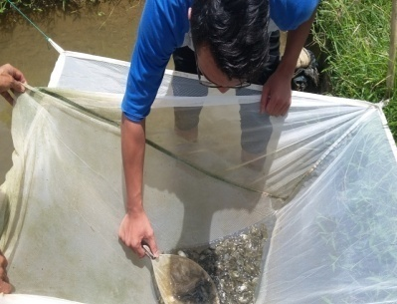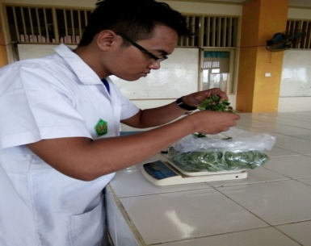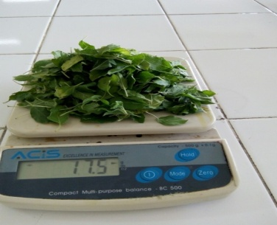
(Pemberokan 24 jam) (Menimbang daun ruku-ruku) (Daun ruku-ruku 17,5 gr)

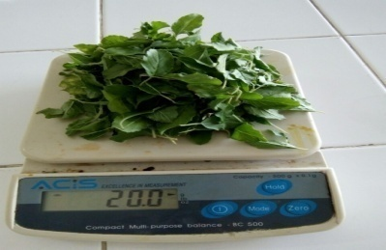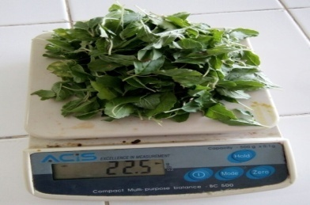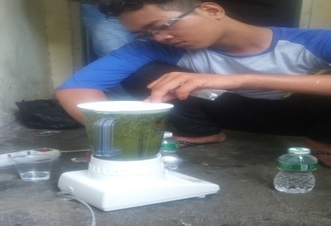
(Daun ruku-ruku 20 gr) (Daun ruku-ruku 22,5 gr) (Memblender daun ruku-ruku)

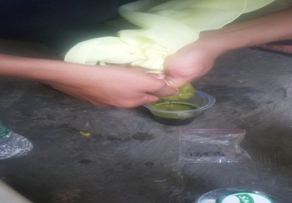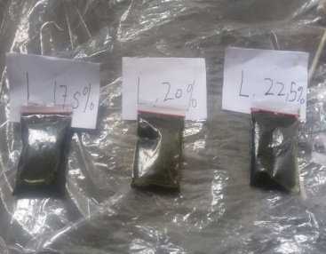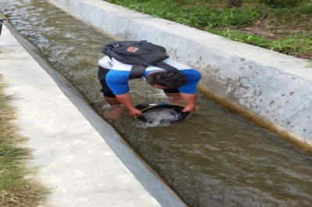
(Menyaring daun ruku-ruku) (Ekstrak daun ruku-ruku) (Pengambilan air)

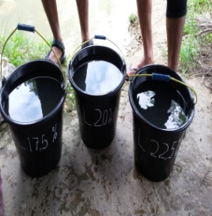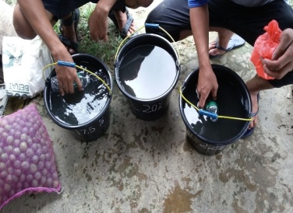
(Air bersih sebelum d masukkan larutan) (Pengambilan sample)
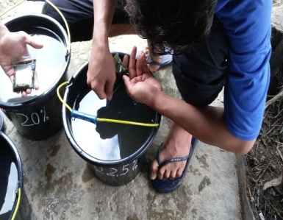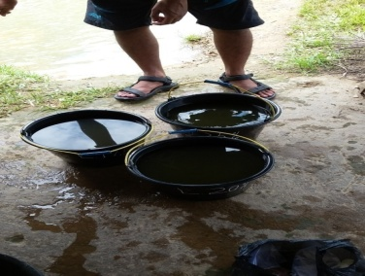
(Melarutkan larutan di setiap 20 L air) (Telah di larutkan 20L air)

Lanjutan lampiran 7.

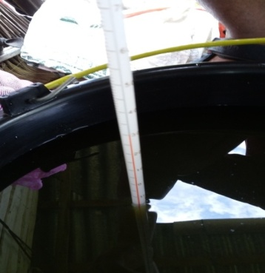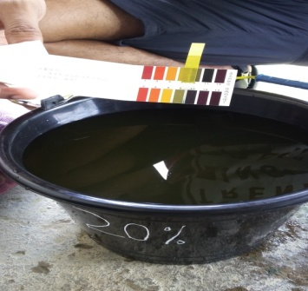
(Mengukur suhu) (Mengukur Ph)

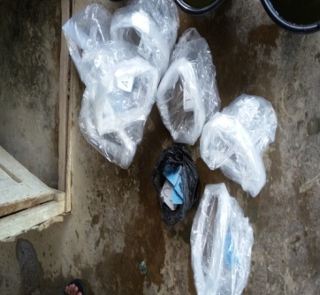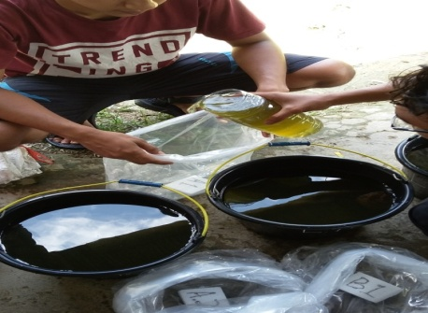
(Persiapan kantong packing) (Memasukan 2L air kedalam packingan)

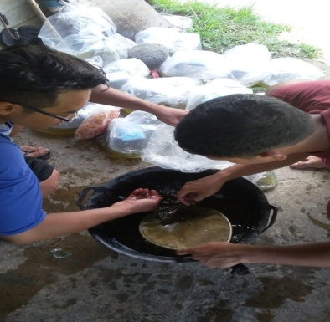 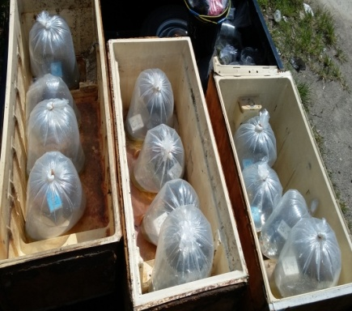 (Memasukkan ikan ke dalam packing) (Packingan didalam sterofoam)

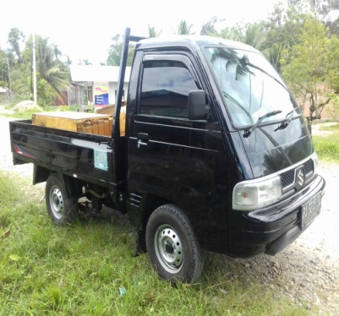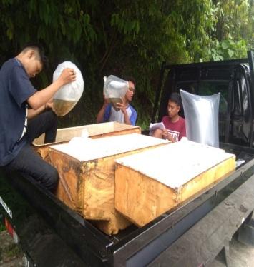

(Kendaraan yang digunakan) (Mencatat suhu dan ikan yang mati)

Lanjutan lampiran 7.

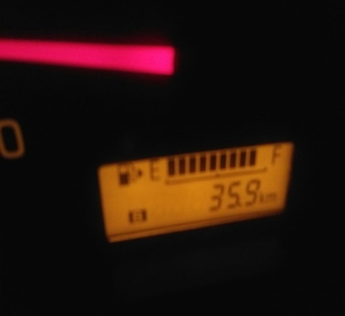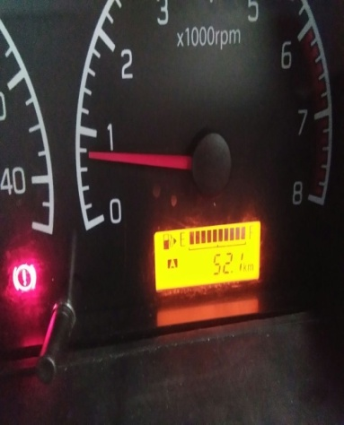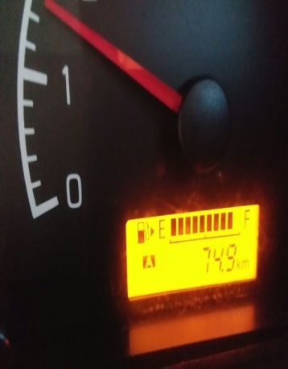
(Kilometer jam ke- 1) (Kilometer jam ke- 2) (Kilometer jam ke- 3)

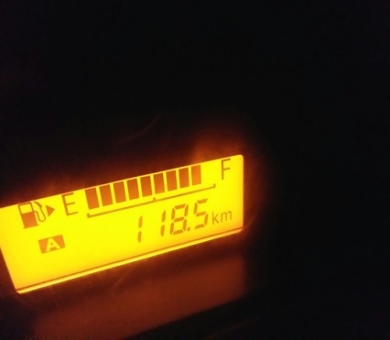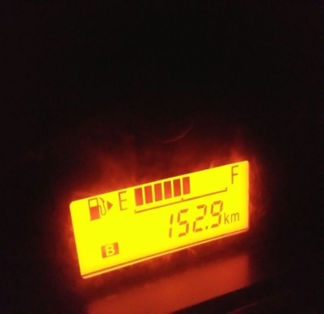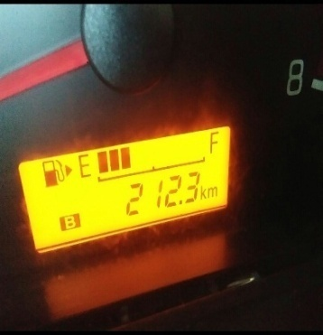
(Kilometer jam ke- 4) ( Kilometer jam ke- 5) (Kilometer jam ke- 6)
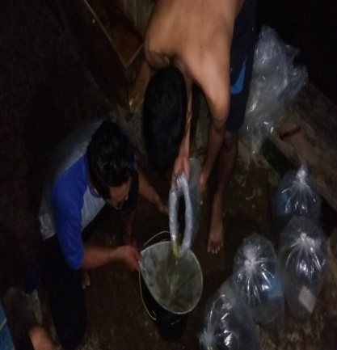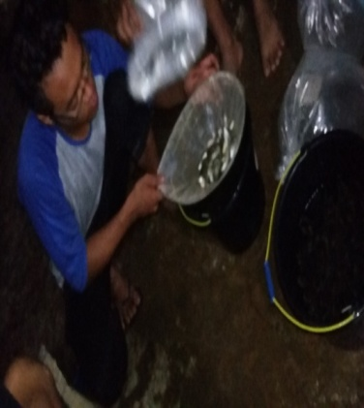
(pemisahan sisa larutan dari packingan) (pemisahan ikan dari packingan)

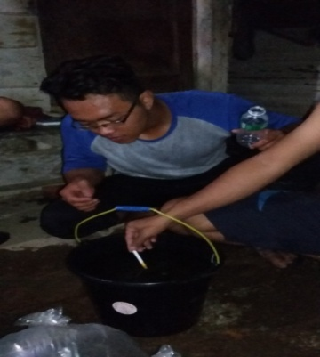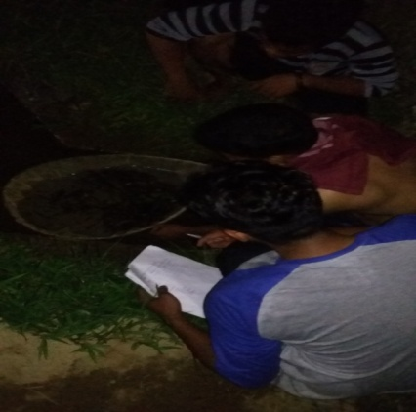
( Cek pH dan dan pengambilan sample air) (Penyadaran ikan diair yang mengalir)

