Lampiran 1
Nama Perusahaan
No | Kode Perusahaaan | Nama Perusahaan
1 | ADES | PT. AKSHA WIRA INTERNATIONAL Tbk
2 | AGII | PT. ANEKA GAS INDUSTRI
3 | AKPI | PT. Argha Karya Prima Tbk
4 | AMFG | PT. ASHIMAS FLAT GLASS Tbk
5 | ASII | PT. ASTRA INTERNASIONAL Tbk
6 | AUTO | PT. ASTRA OTOPARTS Tbk
7 | CEKA | PT. CAHAYA KALBAR Tbk
8 | DLTA | PT. DELTA DJAKARTA Tbk
9 | GGRM | PT. GUDANG DARAM Tbk
10 | HMSP | PT HANJAYA MANDALA SAMPOERNA Tbk.
11 | ICBP | PT INDOFOOD CBP SUKSES MAKMUR Tbk
12 | IGAR | PT. CHAMPION PACIFIC INDONESIA Tbk
13 | INAI | PT. INDAL ALUMUNIUM INDUSTRI Tbk
14 | INDF | PT. INDOFOOD SUKSES MAKMUR Tbk
15 | INTP | PT . INDOCEMENT TUNGGAL PRAKARSA Tbk
16 | JPFA | PT. JAPFA COMFEED INDONESIA Tbk
17 | KAEF | PT. KIMIA FARMA (PERSERO) Tbk
18 | KBLI | PT. KMI WIRE and CABLE Tbk
19 | LMSH | PT. LIONMESH PRIMA Tbk
20 | MERK | PT Merck Tbk
21 | MLBI | PT. MULTI BINTANG INDONESIA Tbk
22 | PICO | PT. PELANGI INDAH CANINDO Tbk
23 | ROTI | PT. NIPPON INDOSARI CORPINDO Tbk
24 | SCCO | PT. SUPREME CABLE MANUFACTURING &COMMERCE Tbk
25 | SKBM | PT . SEKAR BUMI Tbk
26 | SKLT | PT. SEKAR LAUT Tbk
27 | SMGR | PT. SEMEN PADANG INDONESIA (PERSERO) Tbk
28 | SMSM | PT. SELAMAT SEMPURNA Tbk
29 | SQBB | PT. TAISHO PHARMACEUTICAL INDONESIA Tbk
30 | TCID | PT. MANDOM INDONESIA TBK
31 | TOTO | PT. SURYA TOTO INDONESIA TBK
32 | TRIS | PT. TRISULA INTERNATIONAL Tbk
33 | ULTJ | PT. ULTRAJAYA MILK INDUSTRY & TRADING COMPANY Tbk
34 | UNVR | PT. UNILEVER INDONESIA TBK

Lampiran 2
Statistik Deskriptif
Uji Statistik Deskriptif Sebelum Pembuangan Sampel

Descriptive Statistics
 | N | Minimum | Maximum | Mean | Std. Deviation
Y_CETR | 170 | ,00 | 72,00 | 28,2882 | 11,43670
X1_KI | 170 | 32,00 | 98,00 | 74,2647 | 17,21103
X2_KOI | 170 | 25,00 | 80,00 | 38,0176 | 9,78435
X3_KOA | 170 | 3,00 | 6,00 | 3,1353 | ,39139
X4_KRF | 170 | ,00 | 1,00 | ,1294 | ,33665
Valid N (listwise) | 170

Uji Statistik Deskriptif Setelah Pembuangan Sampel
 | N | Minimum | Maximum | Mean | Std. Deviation
Y_CETR | 158 | 9,0000 | 72,0000 | 28,379747 | 9,9895535
X1_KI | 158 | 32,0000 | 98,0000 | 74,537975 | 16,6720469
X2_KOI | 158 | 25,0000 | 80,0000 | 38,291139 | 10,0148322
X3_KOA | 158 | 3,0000 | 6,0000 | 3,145570 | ,4042127
X4_KRF | 158 | ,0000 | 1,0000 | ,120253 | ,3262916
Valid N (listwise) | 158

Lampiran 3
Hasil Uji Asumsi Klasik
Uji Normalitas
Uji Normalitas Normal Menggunakan Unstandardized Residual
One-Sample Kolmogorov-Smirnov Test
 |  | Unstandardized Residual
N |  | 158
Normal Parameters^{a,b} | Mean | .0000000
 | Std. Deviation | 9.56791509
Most Extreme Differences | Absolute | .104
 | Positive | .104
 | Negative | -.047
Kolmogorov-Smirnov Z |  | 1.308
Asymp. Sig. (2-tailed) |  | .065

Uji Normalitas yang tidak Normal
One-Sample Kolmogorov-Smirnov Test
 |  | Y_CETR | X1_KI | X2_KOI | X3_KOA | X4_KRF
N |  | 158 | 158 | 158 | 158 | 158
Normal Parametersª | Mean | 2.837975E1 | 7.453797E1 | 3.829114E1 | 3.145570E0 | .120253
 | Std. Deviation | 9.9895535E0 | 1.6672047E1 | 1.0014832E1 | .4042127 | .3262916
Most Extreme Differences | Absolute | .142 | .119 | .271 | .508 | .524
 | Positive | .142 | .080 | .271 | .508 | .524
 | Negative | -.085 | -.119 | -.235 | -.359 | -.356
Kolmogorov-Smirnov Z |  | 1.782 | 1.498 | 3.406 | 6.382 | 6.580
Asymp. Sig. (2-tailed) |  | .003 | .022 | .000 | .000 | .000

Uji Normalitas Normal Menggunakan Unstandardized Residual
One-Sample Kolmogorov-Smirnov Test
 |  | Unstandardized Residual
N |  | 158
Normal Parameters^{a,b} | Mean | .0000000
 | Std. Deviation | 9.56791509
Most Extreme Differences | Absolute | .104
 | Positive | .104
 | Negative | -.047
Kolmogorov-Smirnov Z |  | 1.308
Asymp. Sig. (2-tailed) |  | .065
Uji Multikolinearitas

Model |  | Collinearity Statistics
 |  | Tolerance | VIF
1 | (Constant)
 | X1_KI | ,911 | 1,098
 | X2_KOI | ,955 | 1,047
 | X3_KOA | ,920 | 1,087
 | X4_KRF | ,982 | 1,019

Uji Autokeralsi
Model | Durbin-Watson
1 | 1.906ª

Uji Heteroskedastisitas
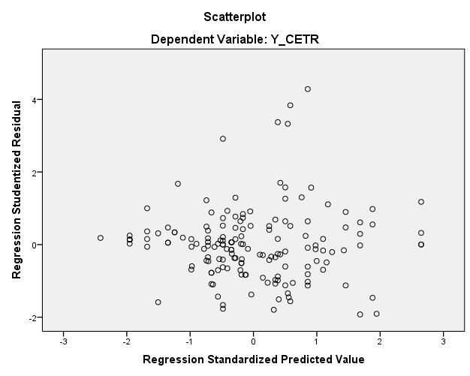
Lampiran 4
Hasil Uji Hipotesis
Koefisiensi Determinasi (R²)

R | R Square | Adjusted R Square | Std. Error of the Estimate
.287ª | .083 | .059 | 9.6921789

Uji t
Model |  | Unstandardized Coefficients |  | Standardized Coefficients | t | Sig.
 |  | B | Std. Error | Beta
1 | (Constant) | ,384 | ,100 |  | 3,862 | ,000
 | KI | -,044 | ,050 | -,072 | -,889 | ,375
 | KOI | -,011 | ,134 | -,007 | -,081 | ,936
 | KOA | -,023 | ,022 | -,088 | -1,076 | ,283
 | KRF | ,037 | ,025 | ,119 | 1,463 | ,145

Uji f
ANOVAª
Model |  | Sum of Squares | df | Mean Square | F | Sig.
1 | Regression | 1294.650 | 4 | 323.663 | 3.445 | .010^{b}
 | Residual | 14372.565 | 153 | 93.938
 | Total | 15667.215 | 157

