LAMPIRAN 1
SAMPEL PENELITIAN

NO. | NAMA BANK UMUM SYARIAH DI INDONESIA | JUMLAH SAMPEL
1. | PT BANK MEGA SYARIAH | 20
2. | PT BANK BNI SYARIAH | 20
3. | PT BANK SYARIAH MANDIRI | 20
4. | PT BANK MUAMALAT INDONESIA | 20
5. | PT BANK BCA SYARIAH | 20
6. | PT BANK BRI SYARIAH | 20
7. | PT BANKJABAR BANTEN SYARIAH | 20
8. | PT BANK PANIN SYARIAH | 20
TOTAL SAMPEL |  | 160

LAMPIRAN 2
HASIL STATISTIK DESKRIPTIF SEBELUM OUTLIER
STASTISTIK DESKRIPTIF SEBELUM OUTLIER

Descriptive Statistics
 | N | Minimum | Maximum | Mean | Std. Deviation
MDH | 160 | .00 | 54.83 | 13.6089 | 12.89363
MSY | 160 | .20 | 180.83 | 37.3504 | 38.18170
MRB | 160 | 19.36 | 167.42 | 89.2459 | 31.31122
IST | 160 | .00 | 1.84 | .1447 | .32613
IJR | 160 | .00 | 49.90 | 5.1882 | 10.02293
RSK | 160 | 14.45 | 50.95 | 29.1188 | 7.87669
PRFIT | 160 | .01 | 100.00 | 2.5883 | 11.08778
Valid N (listwise) | 160
LAMPIRAN 3
HASIL UJI STATISTIK DESKRIPTIF SETELAH OUTLIER
STATISTIK DESKRIPTIF SETELAH OUTLIER
Descriptive Statistics
 | N | Minimum | Maximum | Mean | Std. Deviation
IJR | 155 | 1.03300 | 6.71600 | 4.5957381 | 1.26225412
MDH | 155 | .01400 | 18.38100 | 10.3165629 | 4.20400077
MSY | 155 | .20500 | 104.87200 | 31.0918522 | 26.37138815
MRB | 155 | 21.64400 | 167.41700 | 91.4243806 | 29.31268292
IST | 155 | .00000 | .65900 | .0799829 | .11821549
RSK | 155 | 14.45000 | 48.08300 | 28.5556452 | 7.32092733
PRFIT | 155 | .01100 | 5.67200 | 1.3701935 | 1.45732966
Valid N (listwise) | 155
LAMPIRAN 4
UJI NORMALITAS I

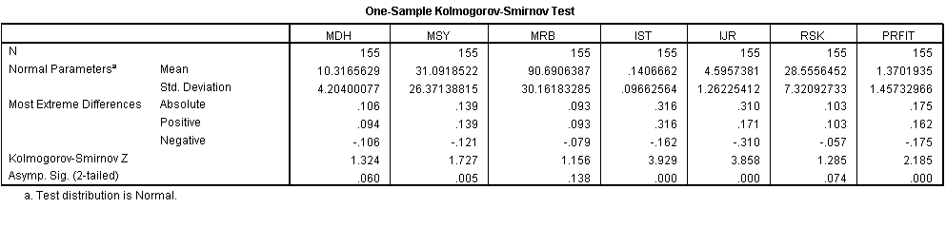

LAMPIRAN 5
HASIL UJI NORMALITAS II
One-Sample Kolmogorov-Smirnov Test
 |  | MDH_OK | MRB_OK | RSK_OK | IJR_OK | IST_OK | PRFT_OK | MSY_OK
N |  | 155 | 155 | 155 | 155 | 155 | 155 | 155
Normal Parametersª | Mean | 1.0316563E1 | 9.0690639E1 | 2.8555645E1 | 2.4382 | 4.8803 | 1.0191 | 5.0176
 | Std. Deviation | 4.20400077E0 | 3.01618328E1 | 7.32092733E0 | 1.61620 | 2.28710 | .57769 | 2.44011
Most Extreme Differences | Absolute | .106 | .093 | .103 | .103 | .100 | .095 | .062
 | Positive | .094 | .093 | .103 | .103 | .100 | .095 | .061
 | Negative | -.106 | -.079 | -.057 | -.069 | -.090 | -.070 | -.062
Kolmogorov-Smirnov Z |  | 1.324 | 1.156 | 1.285 | 1.287 | 1.240 | 1.184 | .773
Asymp. Sig. (2-tailed) |  | .060 | .138 | .074 | .073 | .092 | .121 | .589
LAMPIRAN 6
HASIL UJI MULTIKOLINEARITAS
Coefficientsª
Model |  | Unstandardized Coefficients |  | Standardized Coefficients | T | Sig. | Collinearity Statistics
 |  | B | Std. Error | Beta |  |  | Tolerance | VIF
1 | (Constant) | 1.427 | .226 |  | 6.320 | .000
 | MDH_OK | .037 | .011 | .268 | 3.433 | .001 | .810 | 1.234
 | MSY_OK | .060 | .050 | .254 | 1.206 | .230 | .112 | 8.945
 | MRB_OK | .002 | .002 | .123 | 1.214 | .227 | .479 | 2.088
 | IST_OK | -.046 | .045 | -.181 | -1.012 | .313 | .155 | 6.455
 | IJR_OK | .062 | .029 | .173 | 2.164 | .032 | .775 | 1.289
 | RSK_OK | -.043 | .011 | -.546 | -3.958 | .000 | .259 | 3.854

LAMPIRAN 7
HASIL UJI AUTOKORELASI

Model Summary^{b}
Model | R | R Square | Adjusted R Square | Std. Error of the Estimate | Durbin-Watson
1 | .518ª | .268 | .239 | .50405 | .645

LAMPIRAN 9
HASIL UJI R²

Model Summary^{b}
Model | R | R Square | Adjusted R Square | Std. Error of the Estimate | Durbin-Watson
1 | .518ª | .268 | .239 | .50405 | .645

LAMPIRAN 10
HASIL UJI F

ANOVA^{b}
Model |  | Sum of Squares | Df | Mean Square | F | Sig.
1 | Regression | 13.792 | 6 | 2.299 | 9.047 | .000ª
 | Residual | 37.603 | 148 | .254
 | Total | 51.394 | 154

LAMPIRAN 11
HASIL UJI T
Coefficientsª
Model |  | Unstandardized Coefficients |  | Standardized Coefficients | t | Sig. | Collinearity Statistics
 |  | B | Std. Error | Beta |  |  | Tolerance | VIF
1 | (Constant) | 1.427 | .226 |  | 6.320 | .000
 | MDH_OK | .037 | .011 | .268 | 3.433 | .001 | .810 | 1.234
 | MSY_OK | .060 | .050 | .254 | 1.206 | .230 | .112 | 8.945
 | MRB_OK | .002 | .002 | .123 | 1.214 | .227 | .479 | 2.088
 | IST_OK | -.046 | .045 | -.181 | -1.012 | .313 | .155 | 6.455
 | IJR_OK | .062 | .029 | .173 | 2.164 | .032 | .775 | 1.289
 | RSK_OK | -.043 | .011 | -.546 | -3.958 | .000 | .259 | 3.854

LAMPIRAN 8
HASIL UJI HETEROSKEDASTISITAS

Model Summary^{b}
Model | R | R Square | Adjusted R Square | Std. Error of the Estimate
1 | .518ª | .268 | .239 | .50405

ANOVA^{b}
Model |  | Sum of Squares | Df | Mean Square | F | Sig.
1 | Regression | 13.792 | 6 | 2.299 | 9.047 | .000ª
 | Residual | 37.603 | 148 | .254
 | Total | 51.394 | 154
