**Uji Asumsi Klasik**

1. **Uji Normalitas**

| **One-Sample Kolmogorov-Smirnov Test** | | | | | | |
| --- | --- | --- | --- | --- | --- | --- |
|  |  | Y | X1 | X2 | X3 | X4 |
| N | | 80 | 80 | 80 | 80 | 80 |
| Normal Parametersa | Mean | 21.6750 | 28.1250 | 32.6125 | 20.9250 | 31.2500 |
| Std. Deviation | 2.21488 | 1.31568 | 3.57025 | 2.54963 | 2.46751 |
| Most Extreme Differences | Absolute | .150 | .150 | .143 | .142 | .119 |
| Positive | .150 | .150 | .089 | .142 | .093 |
| Negative | -.150 | -.134 | -.143 | -.117 | -.119 |
| Kolmogorov-Smirnov Z | | 1.344 | 1.345 | 1.281 | 1.267 | 1.068 |
| Asymp. Sig. (2-tailed) | | .054 | .054 | .075 | .081 | .204 |
| a. Test distribution is Normal. | |  |  |  |  |  |
|  |  |  |  |  |  |  |

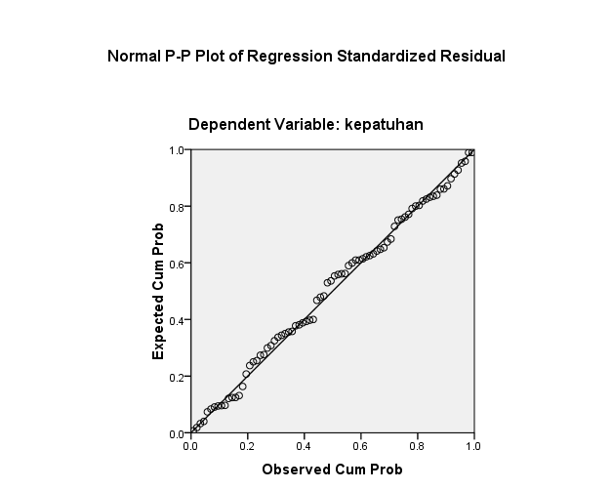

**2.Uji Multikolinearitas**

| **Coefficientsa** | | | | | | | | |
| --- | --- | --- | --- | --- | --- | --- | --- | --- |
| Model | | Unstandardized Coefficients | | Standardized Coefficients | t | Sig. | Collinearity Statistics | |
| B | Std. Error | Beta | Tolerance | VIF |
| 1 | (Constant) | 11.949 | 5.852 |  | 2.042 | .045 |  |  |
| pengetahuan dan pemahaman | -.214 | .164 | -.127 | -1.301 | .197 | .934 | 1.071 |
| motivasi | .118 | .071 | .190 | 1.664 | .100 | .684 | 1.462 |
| pemeriksaan | .075 | .096 | .086 | .779 | .438 | .726 | 1.378 |
| self assesment system | .331 | .103 | .368 | 3.216 | .002 | .679 | 1.473 |
| a. Dependent Variable: kepatuhan | | |  |  |  |  |  |  |

1. **Uji Heteroskedasitas**

| **Coefficientsa** | | | | | | | | |
| --- | --- | --- | --- | --- | --- | --- | --- | --- |
| Model | | Unstandardized Coefficients | | Standardized Coefficients | t | Sig. | Collinearity Statistics | |
| B | Std. Error | Beta | Tolerance | VIF |
| 1 | (Constant) | 3.960 | 3.454 |  | 1.146 | .255 |  |  |
| pengetahuan dan pemahaman | -.046 | .097 | -.056 | -.470 | .640 | .934 | 1.071 |
| motivasi | -.015 | .042 | -.050 | -.363 | .718 | .684 | 1.462 |
| pemeriksaan | -.022 | .057 | -.052 | -.388 | .699 | .726 | 1.378 |
| self assesment system | -.009 | .061 | -.020 | -.145 | .885 | .679 | 1.473 |
| a. Dependent Variable: abs_res | | |  |  |  |  |  |  |